Activity QL khách hàng (Thêm, xóa):
https://lucid.app/lucidchart/018c2fb7-e784-4334-9b73-963425d75e0a/edit?viewport_loc=-191%2C-816%2C3605%2C1946%2C0_0&invitationId=inv_f9805211-89ad-404f-876c-fcb558fae6d8
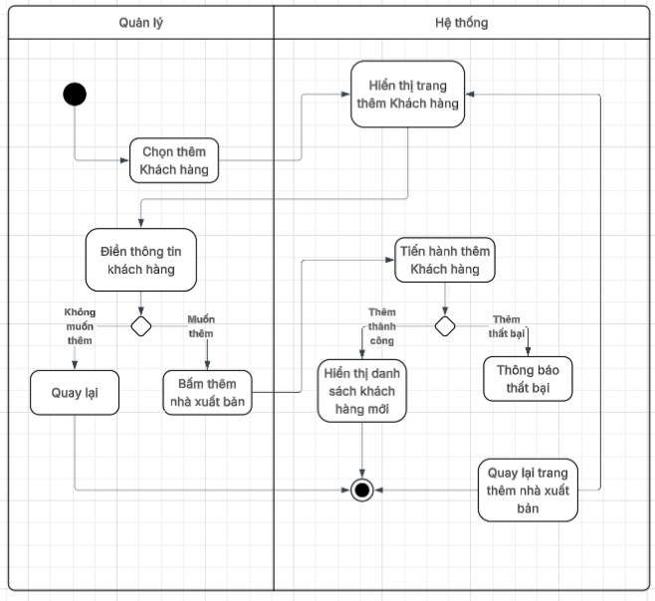
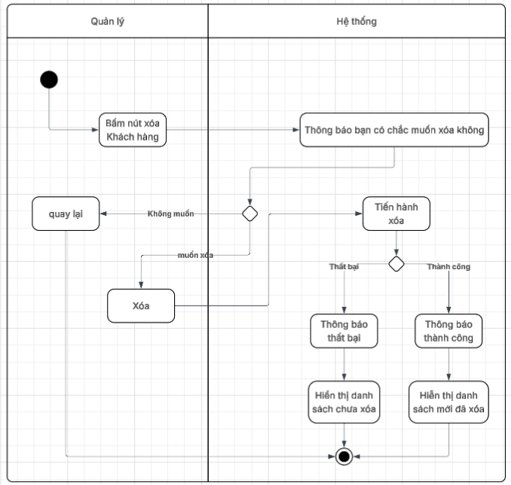
Activity QL khách hàng (tìm kiếm, sửa):
https://lucid.app/lucidchart/dd783ed8-df99-4f47-8244-4996e5cc8b01/edit?viewport_loc=534%2C-651%2C2399%2C1295%2C0_0&invitationId=inv_f162139b-b9f1-47ab-8674-0b8c4982bb5b
